JAVA PROJECT

INTRODUCTION:
Airport Flight Board & Scheduler is a Java-based application designed to help users easily check and manage flight information at an airport. The program stores information about a fixed number of flights and allows users to search for a particular flight and view its details.
The system can display important information such as flight number, origin, destination, boarding/departure time, arrival time, gate number, date, flight status, and available seats.
The main purpose of this project is to provide users with a simple and organized flight information system using Java programming concepts such as arrays, loops, conditional statements, switch statements, methods, and user input using Scanner.
Main Functions
- View Flights – Displays the available flights at the airport.
- Search Flight – Allows the user to search for a flight using its flight number.
- Flight Details – Shows the origin, destination, boarding/departure time, arrival time, gate, date, and status.
Project Objective
The objective of this project is to develop a user-friendly Java program that provides quick access to airport flight information and demonstrates how Java programming can be used to develop a simple real-world application.

CODE FOR Airport Flight Board & Scheduler :
import java.util.Scanner;

public class AirportFlightBoard {

public static void main(String[] args) {

Scanner sc = new Scanner(System.in);

System.out.println("========================================");
System.out.println(" AIRPORT FLIGHT BOARD & SCHEDULER");
System.out.println("========================================");

System.out.println("\nAvailable Flights:");
System.out.println("AI101 - Hyderabad to Delhi");
System.out.println("6E205 - Mumbai to Bengaluru");
System.out.println("SG310 - Chennai to Delhi");
System.out.println("AI405 - Delhi to Hyderabad");
System.out.println("6E512 - Bengaluru to Mumbai");
System.out.println("UK620 - Kolkata to Chennai");
System.out.println("SG725 - Pune to Hyderabad");

System.out.print("\nEnter Flight Number: ");
String flight = sc.nextLine();

if (flight.equalsIgnoreCase("AI101")) {

System.out.println("\nFlight Details");
System.out.println("Flight Number : AI101");
System.out.println("From : Hyderabad");
System.out.println("To : Delhi");
System.out.println("Boarding Time : 10:00 AM");
System.out.println("Departure Time: 10:30 AM");

} else if (flight.equalsIgnoreCase("6E205")) {

System.out.println("\nFlight Details");
System.out.println("Flight Number : 6E205");
System.out.println("From : Mumbai");
System.out.println("To : Bengaluru");
System.out.println("Boarding Time : 11:00 AM");
System.out.println("Departure Time: 11:30 AM");

} else if (flight.equalsIgnoreCase("SG310")) {

System.out.println("\nFlight Details");
System.out.println("Flight Number : SG310");
System.out.println("From : Chennai");
System.out.println("To : Delhi");
System.out.println("Boarding Time : 12:30 PM");
System.out.println("Departure Time: 01:00 PM");

} else if (flight.equalsIgnoreCase("AI405")) {

System.out.println("\nFlight Details");
System.out.println("Flight Number : AI405");
System.out.println("From : Delhi");
System.out.println("To : Hyderabad");
System.out.println("Boarding Time : 02:00 PM");
System.out.println("Departure Time: 02:30 PM");

} else if (flight.equalsIgnoreCase("6E512")) {

System.out.println("\nFlight Details");
System.out.println("Flight Number : 6E512");
System.out.println("From : Bengaluru");
System.out.println("To : Mumbai");
System.out.println("Boarding Time : 03:30 PM");
System.out.println("Departure Time: 04:00 PM");

} else if (flight.equalsIgnoreCase("UK620")) {

System.out.println("\nFlight Details");
System.out.println("Flight Number : UK620");
System.out.println("From : Kolkata");
System.out.println("To : Chennai");
System.out.println("Boarding Time : 05:00 PM");
System.out.println("Departure Time: 05:30 PM");

} else if (flight.equalsIgnoreCase("SG725")) {

System.out.println("\nFlight Details");
System.out.println("Flight Number : SG725");
System.out.println("From : Pune");
System.out.println("To : Hyderabad");
System.out.println("Boarding Time : 06:30 PM");
System.out.println("Departure Time: 07:00 PM");

} else {

System.out.println("\nFlight not found!");

}

sc.close();
}
}

Output For Enter Flight Number: AI101

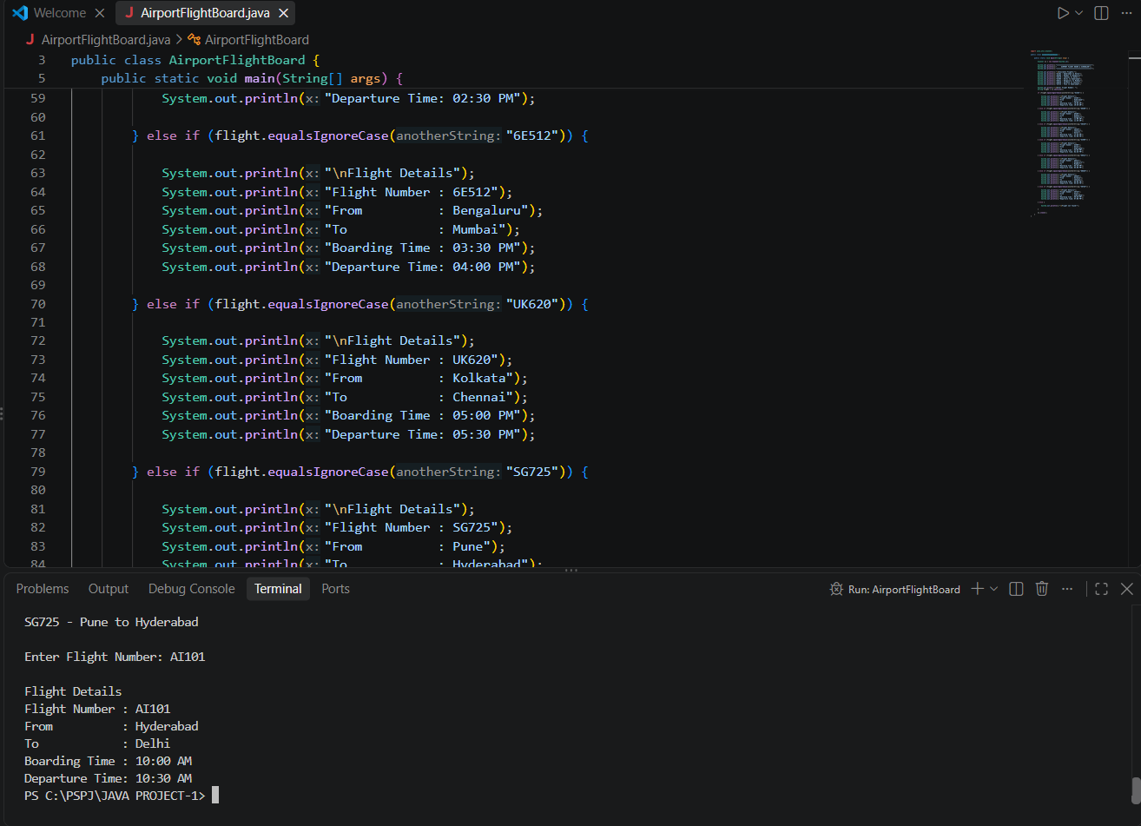

ABSTRACT:
The Airport Flight Board & Scheduler is a Java-based application developed to provide users with quick and organized access to airport flight information. The system maintains details of multiple flights, including flight number, origin, destination, boarding and departure time, arrival time, gate number, date, flight status, and available seats. Users can view the available flights and search for a specific flight using its flight number. The program uses fundamental Java concepts such as arrays, loops, conditional statements, switch statements, strings, and user input through the Scanner class. The main objective of this project is to demonstrate how Java programming can be used to develop a simple real-world airport information system that is easy to understand and use. This project can also be further extended with features such as adding new flights, updating flight status, booking seats, and managing flight schedules.

Problem Statement:
Airports handle a large amount of flight information every day, including flight numbers, departure and arrival locations, boarding times, gates, flight status, dates, and seat availability. Checking this information manually can be difficult and time-consuming for passengers.
The Airport Flight Board & Scheduler project aims to develop a simple Java-based system that allows users to easily view and search for flight information. The system will maintain details of multiple flights and provide users with the required information based on their selected flight number.
The project focuses on creating an easy-to-use system that demonstrates how Java programming can be applied to solve a real-world problem involving the organization and retrieval of flight information.

CONCLUTION:
The Airport Flight Board & Scheduler project successfully demonstrates how Java programming can be used to develop a simple and useful airport flight information system. The program allows users to view available flights and search for specific flight details such as flight number, origin, destination, boarding time, departure time, arrival time, gate number, flight status, date, and available seats.
Through this project, fundamental Java concepts such as arrays, loops, conditional statements, switch statements, strings, and user input using the Scanner class are applied to a real-world problem. The project provides a simple and organized way for users to access flight information.
In the future, the system can be enhanced by adding features such as flight booking, seat reservation, adding and deleting flights, updating flight status, automatic scheduling, and database connectivity. Overall, this project provides a strong foundation for developing a more advanced airport management system using Java.

